SQL Server job for IMAPS Division 16 PLC_RATES interface

Job name: D16_PLC Rate Update

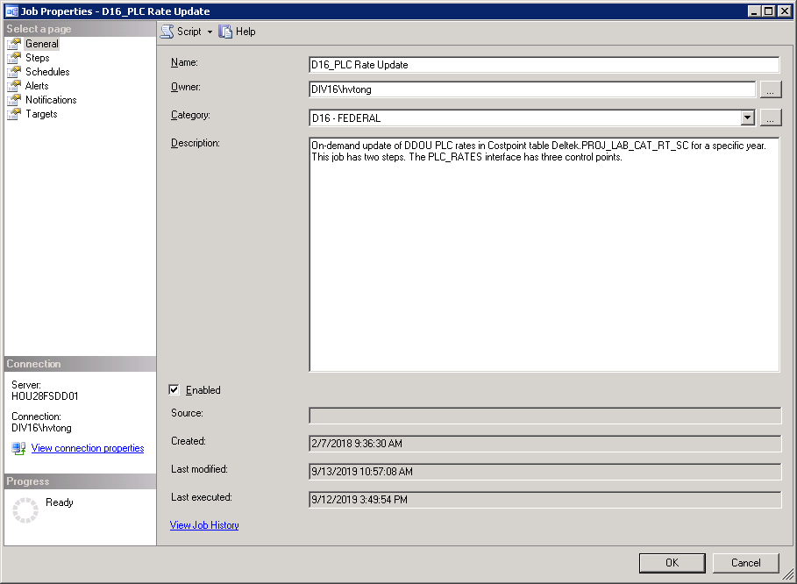

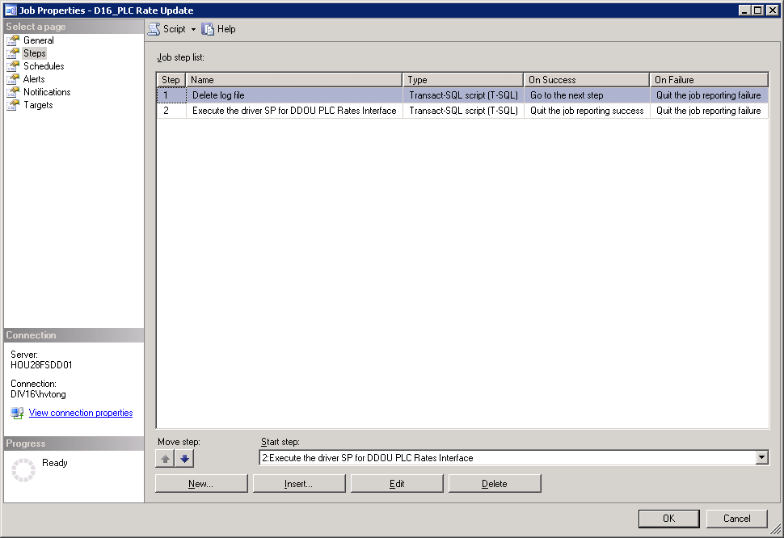

Step 1: Delete log file

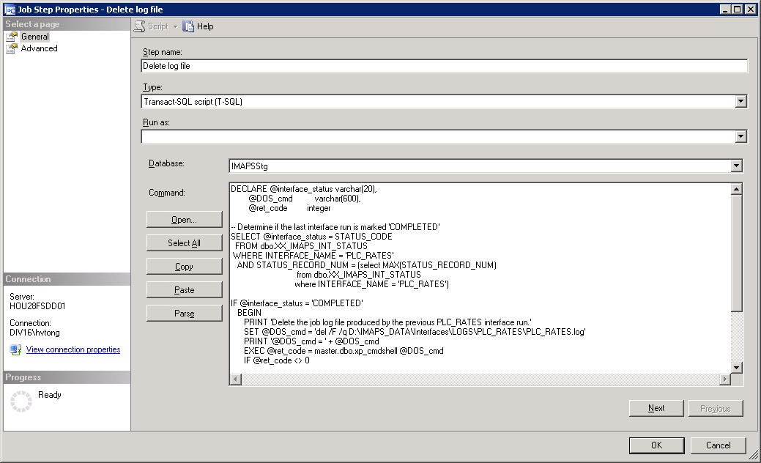

DECLARE @interface_status varchar(20),

@DOS_cmd varchar(600),

@ret_code integer

-- Determine if the last interface run is marked 'COMPLETED'

SELECT @interface_status = STATUS_CODE

FROM dbo.XX_IMAPS_INT_STATUS

WHERE INTERFACE_NAME = 'PLC_RATES'

AND STATUS_RECORD_NUM = (select MAX(STATUS_RECORD_NUM)

from dbo.XX_IMAPS_INT_STATUS

where INTERFACE_NAME = 'PLC_RATES')

IF @interface_status = 'COMPLETED'

BEGIN

PRINT 'Delete the job log file produced by the previous PLC_RATES interface run.'

SET @DOS_cmd = 'del /F /q D:\IMAPS_DATA\Interfaces\LOGS\PLC_RATES\PLC_RATES.log'

PRINT '@DOS_cmd = ' + @DOS_cmd

EXEC @ret_code = master.dbo.xp_cmdshell @DOS_cmd

IF @ret_code <> 0

RAISERROR('Attempt to delete the job log file produced by the previous PLC_RATES interface run failed.', 16, 1)

END

ELSE

BEGIN

PRINT '**********************************************************'

PRINT '* PICKING UP WHERE WE LEFT OFF *'

PRINT '**********************************************************'

END

Step 2: Execute the driver SP for DDOU PLC Rates Interface

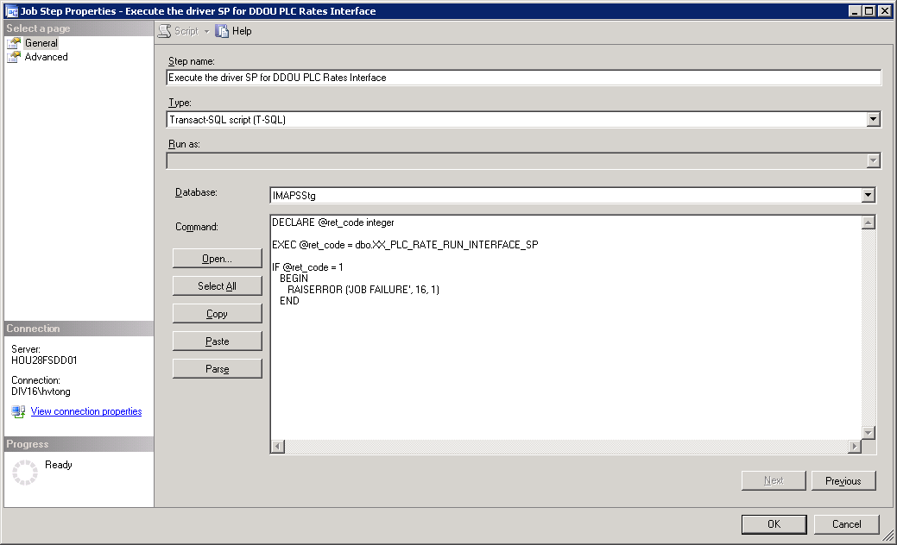

DECLARE @ret_code integer

EXEC @ret_code = dbo.XX_PLC_RATE_RUN_INTERFACE_SP

IF @ret_code = 1

BEGIN

RAISERROR('JOB FAILURE', 16, 1)

END